Name
Course
Institution]
Professor
Date

Instruction
For this homework, you need to create a series of flowcharts based on the problems below. You will then answer a series of quiz questions based on the flowcharts you develop. However, in order to keep the points you earn for the quiz, you must upload all of your completed flowcharts at the end of the quiz. Note: you can create the flowcharts in Lucid Chart, paper, or anything else as long as they are legible. If you create them in Lucid Chart, then export them as images and upload them as a single file (either by zipping them up together or pasting them into a Word document). If you create them on paper, then take pictures of them with your phone and upload them the same way. Remember, we must be able to read and interpret them. Create flowcharts for the following three scenarios: Baking
- Cookies. Sweet Dough Inc. bakes cookies—a popular dessert—based on the quantities ordered by their customers. Three raw materials are used to bake: Flour, Eggs, and Sugar. To produce 1kg of Cookie dough, they need 400 grams of Sugar, 800 grams of Flour, and the number of Eggs equal to the amount of Cookie dough desired raised to the .6 power. Management has decided to develop a computer program to correctly calculate the amount of Flour, Sugar, and Eggs to purchase in order to meet their customers’ demands for Cookie dough. Create a flowchart to show the logic of a computer program that can receive (as an input) a desired amount of Cookie Dough (in kilograms), calculate the required amount of each ingredient, and output each amount.
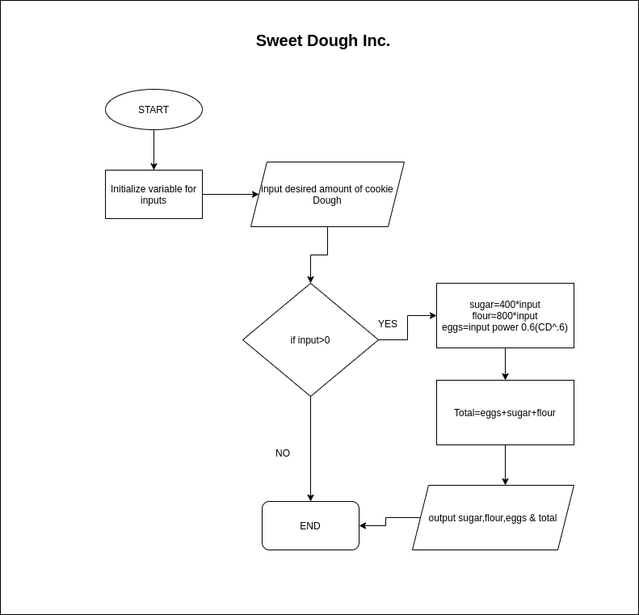

- College Tuition. Assume you have been asked to develop an algorithm to calculate the price of tuition for incoming college students. An example spreadsheet is given and described below. There are two variables that affect the price of tuition: (1) a $1,000 scholarship that students may have received and (2) whether the student lives in-state or out-of-state of the school. The initial cost of tuition before any deductions is $5,000. In each case, a check is placed in the appropriate box in the spreadsheet to the right. When a checkbox is checked, it reflects that the student has a scholarship or lives in-state (is True, in Boolean terms). When the checkbox is not checked, it reflects that the student does not have a scholarship or lives out-of-state (is False, in Boolean terms). One or both discounts can be selected. Assume that your algorithm will only be used when at least one of the discounts apply. In other words, you don't have to account in your algorithm for the case where neither

discount applies. In other words, all students that live out of state received the $1,000 scholarship and anyone who didn’t receive the scholarship lives in-state. The table below shows the ONLY THREE scenarios your flowchart needs to handle. Whether the student gets a scholarship (Scholarship = True or False) and whether or not the student lives in-state (Instate = True or False) are inputs for each student (i.e. pass through the flowchart). The university financial office adds a checkmark to the Setup section for all the students that received the $1,000 scholarship. The financial office then adds a checkmark if the student lives in or out of state. The initial cost of tuition for all students is $5,000. If the student lives in state, the student’s tuition is $3,500. Any students that received the scholarship will pay $1,000 less of the final total (i.e. in-state students pay $2,500 and out-of-state students would pay $4,000). When you design your flowchart, assume that the variables Scholarship and Instate are Boolean variables (They can only be True or False). Your flowchart should process first whether the student received the scholarship then second whether they live in-state or not. In Scenario 1, the student did receive the scholarship and lives out-of-state. In scenario 2, the student did not receive the scholarship and lives in-state. In scenario 3, the student received the scholarship and lives in-state. Jim’s Years to Accumulate.
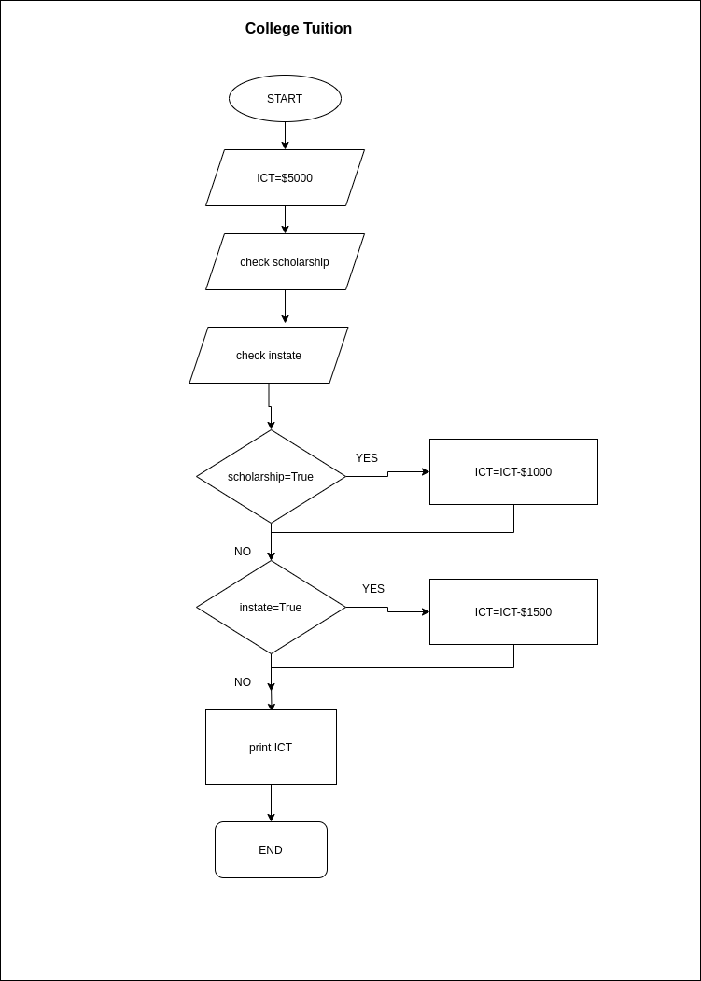
- Jim often counsels customers at his bank. He needs a computer program that will calculate the number of years (Y) it will take to accumulate a specified future amount (S) of money based on a given initial deposit (D) and specified interest rate (R). Assume interest compounds annually. The number of years (Y) is the number of years required for the actual amount (A) to equal or exceed the specified future amount (S). Here is the variable legend: Use this formula to calculate A: A = D * (1 + R/100)^Y The Actual Future Amount (A) is = an Initial Deposit (D) after (Y) years at a Rate (R) Draw a flowchart for an algorithm to produce the answers. Your flowchart should input S, D, and R. The algorithm should output S, D, R, A, and Y. Use looping (i.e., “repetition” or “iteration”) in your program. In other words, your flowchart should continue looping until the actual balance (A) is equal to or greater than the specified (S) future amount. NOTE: there is a faster way to complete this problem that doesn't require looping. However, while it's cool if you can figure that out (it's basically just a matter of using the right formula), that's not the point of this task. We want you to learn how to create a loop with a termination. In addition to creating the flowchart, create a loop termination table with appropriate values (based on the example values below) to demonstrate that your algorithm uses a correct loop termination condition. Example Inputs for Loop Termination Table: S = 1300 D = 1000 R = 10 S = Specified Future Amount D = Initial Deposit R = Interest Rate (%) A = Actual Future Amount Y = Number of Years
